
DTSC-625: Data Engineering in the Cloud

SUBMISSION TEMPLATE:

LakeFormation Lab
Curtis Nielson

Complete the following template and upload to the assignment on Brightspace.

In every screenshot, include your AWS username that appears in the upper right corner. You must use either your full name or your Eastern University email address as your AWS username. Example:

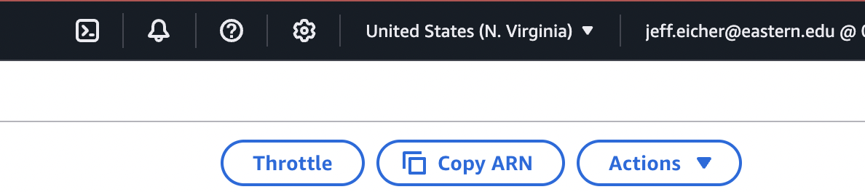

If any one screenshot is missing this identification, the entire assignment will be scored no higher than 70%.

Points totals are provided at the start of each question. You score either full credit or 0 points; there is no partial credit for each question.

- [20 points] In the space below, provide a screenshot of the PII file in the correct location (after Step 1).
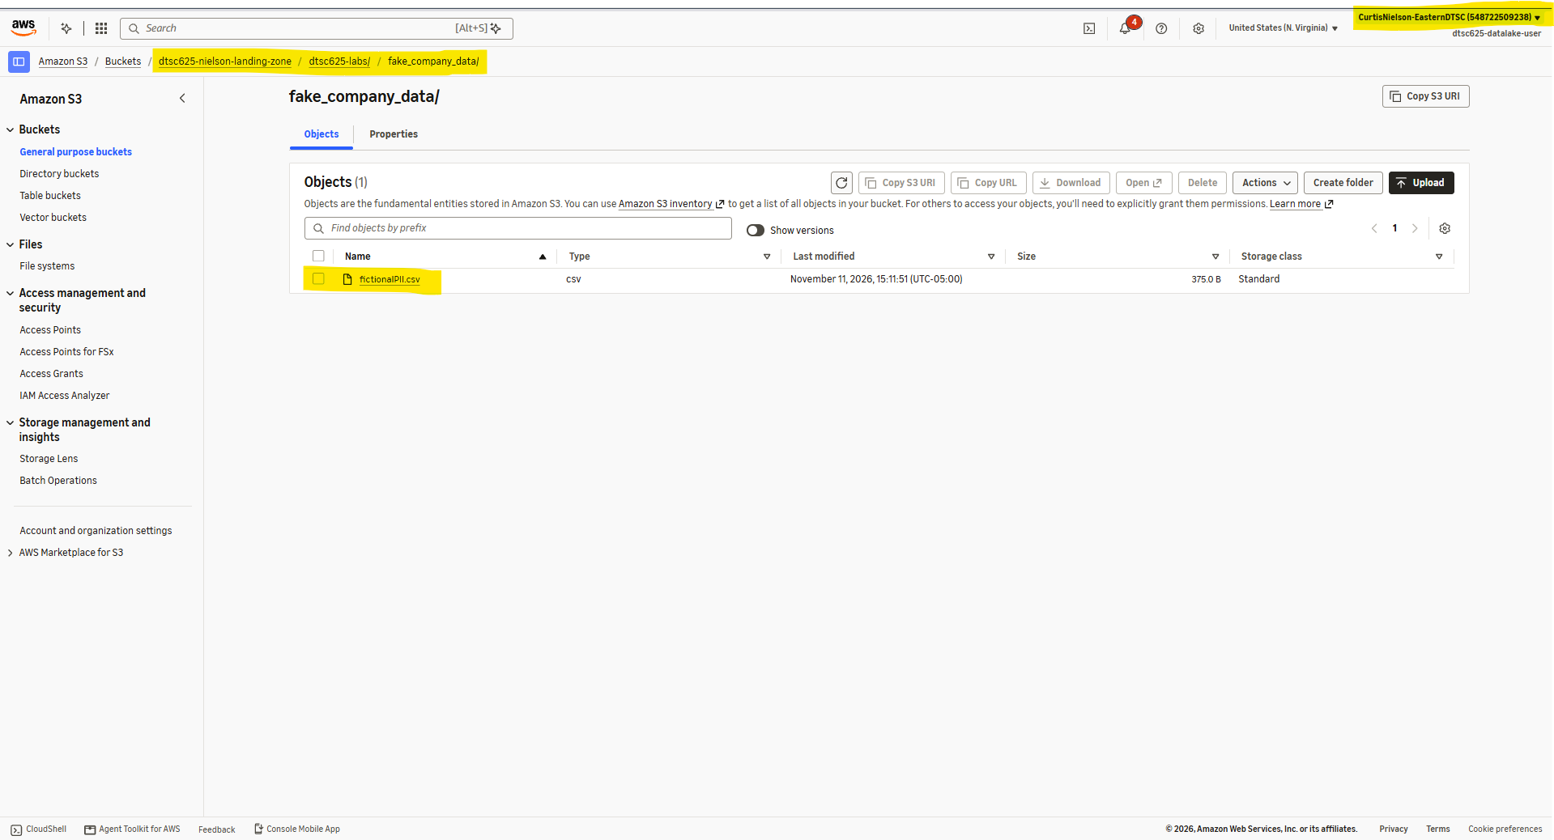
It was unclear whether you wanted the location of the .csv file, or the parquet file, so I’ve provided both.
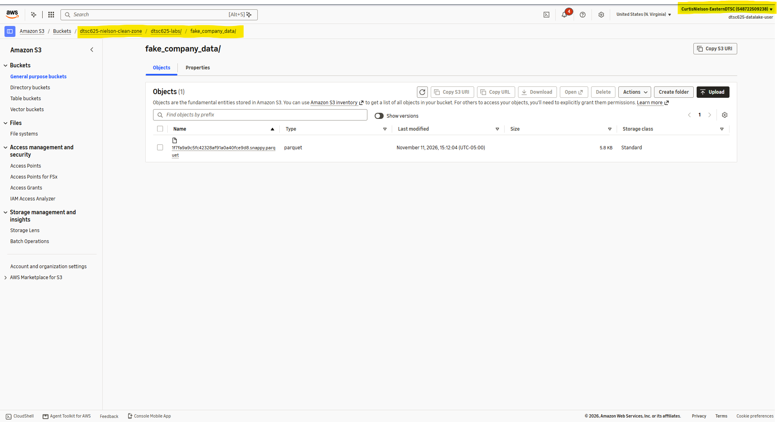

- [20 points] In the space below, provide a screenshot of your S3 bucket for Athena results (after Step 2).

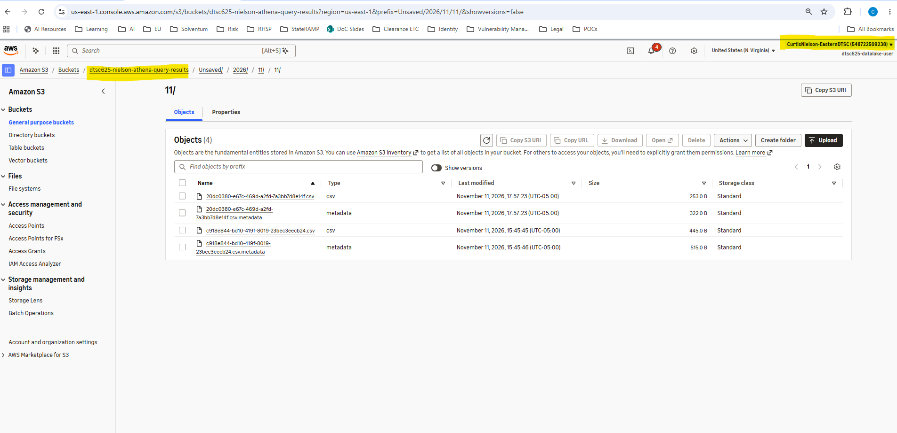

- [30 points] In the space below, provide a screenshot of your datalake-user submitting a query in Athena (after Step 5). Students must show their query & the results of the query within the screenshot.

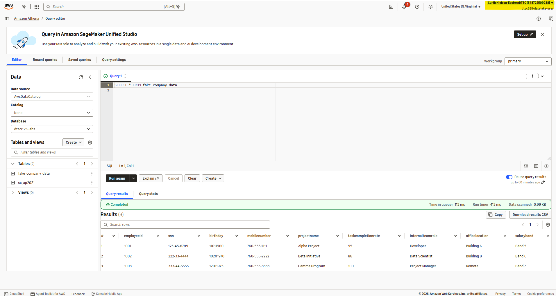

- [30 points] In the space below, provide a screenshot of your datalake-user accessing the PII file, but with the PII information not showing (after Step 8). Students must show their query & the results of the query within the screenshot.



